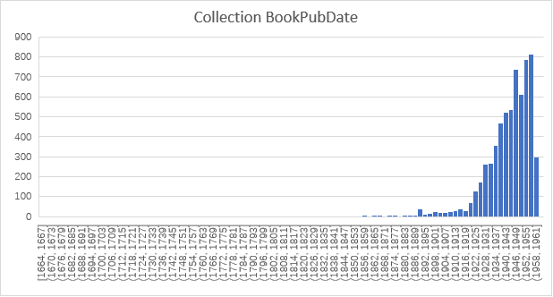

**Ernest Miller Hemingway** (1899 – 1961)

an American novelist, short story writer, and journalist

**His book:**

First book: 1923 *Three Stories and Ten Poems*---we can see the amount of books he collects around this time start to rise.

He produced most of his work between the mid-1920s and the mid-1950s, and he won the [Nobel Prize in Literature](https://en.wikipedia.org/wiki/Nobel_Prize_in_Literature) in 1954

--- we can see most of his books collected during these periods of time.

**Marriage:**

1921, he married [Hadley Richardson](https://en.wikipedia.org/wiki/Hadley_Richardson), the first of his four wives. The couple moved to Paris, where he worked as a [foreign correspondent](https://en.wikipedia.org/wiki/Correspondent) and fell under the influence of the [modernist](https://en.wikipedia.org/wiki/Modernism) writers and artists of the 1920s

**Main experiences:**

Born: **1899**  [Oak Park, Illinois](https://en.wikipedia.org/wiki/Oak_Park,_Illinois), a suburb of **Chicago**

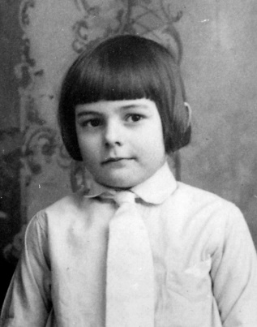

**1913-1917**, Hemingway attended [Oak Park and River Forest High School](https://en.wikipedia.org/wiki/Oak_Park_and_River_Forest_High_School)—**Chicago**

### 1918 ,World War I , he was at the [Italian Front](https://en.wikipedia.org/wiki/Italian_Front_(World_War_I))---Italian

### 

### 1920 A family friend offered him a job in [Toronto](https://en.wikipedia.org/wiki/Toronto). Late that year he began as a freelancer, staff writer, and foreign correspondent for the Toronto Star Weekly--[Toronto](https://en.wikipedia.org/wiki/Toronto)

### 1920-1921, He move back to Chicago to live with friends ,while still filing stories for the [*Toronto Star*](https://en.wikipedia.org/wiki/Toronto_Star)*,* in 1921, he married [Hadley Richardson](https://en.wikipedia.org/wiki/Hadley_Richardson).-- Chicago

### 1921-1923, in 1923, his first book *Three Stories and Ten Poems* was published in Paris.

### 1923-1924 move back to Toronto --- Toronto

### 1924-1927 Hemingway married Pfeiffer in 1927---Paris

### 1928 He Travelled to Kansas, Wyoming, Massachusetts, and New York

### 1929 Spain

### 1930 He spent his winters in Key West and summers in Wyoming

### 1931 Kansas

### 1933 Hemingway and Pauline went on safari to East Africa

### 1934 Hemingway bought a boat  and began sailing the [Caribbean](https://en.wikipedia.org/wiki/Caribbean).

### 1935 He first arrived at [Bimini](https://en.wikipedia.org/wiki/Bimini), where he spent a considerable amount of time.---[Bimini](https://en.wikipedia.org/wiki/Bimini)

### 1937-1938 Spanish Civil War--- Spanish

### 1939-1945 1941 World War II He married Mary Welsh Hemingway --- Cuba Havana

### 1944-1945 London and Europe

### 1946-1952 Cuba Havana

### 1952-1956 Shortly after the publication of [*The Old Man and the Sea*](https://en.wikipedia.org/wiki/The_Old_Man_and_the_Sea) (1952), Hemingway went on [safari](https://en.wikipedia.org/wiki/Safari) to Africa

### 1956 Paris

### 1957 Cuba Havana

### 1959 Spain--Cuba

### 1959-1961 He committed suicide in his home. --Ketchum

### 

**Hemingway’s friendship:**

<https://www.jfklibrary.org/Research/The-Ernest-Hemingway-Collection/Online-Resources/Storytellers-Legacy.aspx?p=7>

**Hemingway’s writing style was affected by:**

Gertrude Stein (1874-1946) 她拥有E.H 3本书

E.H 拥有她的8本书

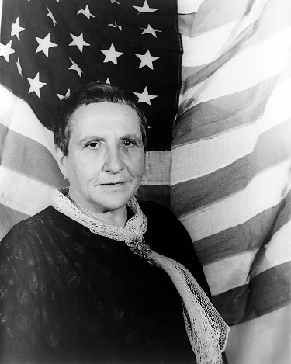

As one of the ruling literary figures in Paris, Stein welcomed Hemingway to her circle and offered him advice on many matters including writing and sex, which he recounted somewhat cruelly in A Moveable Feast.

F. Scott Fitzgerald（1896-1940）(海明威拥有他的11本书)

When Hemingway arrived in Paris, Fitzgerald was already there, wealthy and successful as a writer. Fitzgerald welcomed the younger writer. They talked writing, and the two couples socialized.

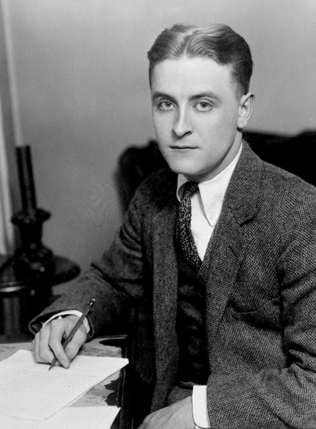

Ezra Pound (1885-1972)（E.H拥有他的30本书）

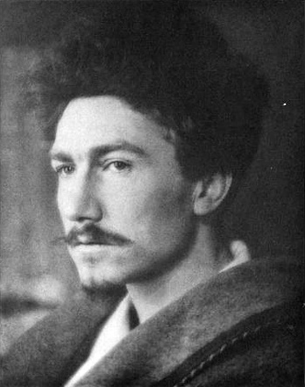

They are good friends all the time. During World War II Pound lived in Italy and sided with the Italian fascists. After the war, when charges of treason were being leveled at Pound, Hemingway helped get Pound released from St. Elizabeth's Hospital, the psychiatric hospital in Washington, D.C., so he could return to Italy and spend his remaining years with his daughter.

Georges Simenon(1903-1989) (E.H拥有他的43本书—the largest amount)

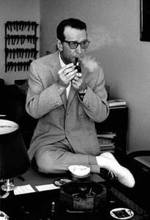

Ernest Hemingway admired and enjoyed Simenon's work, --so it makes sense that Simenon's work is the most popular in Ernest Hemingway’s library.

BookCollection：

**Most of the book collected from Finca Vigía(6057本) and Key West(1671本)**

Finca Vigíawas the home of [Ernest Hemingway](https://en.wikipedia.org/wiki/Ernest_Hemingway)  in [Havana](https://en.wikipedia.org/wiki/Havana), [Cuba](https://en.wikipedia.org/wiki/Cuba). Hemingway spend about 20 years there.

Both Finca Vigía and Hemingway's [Key West home](https://en.wikipedia.org/wiki/Ernest_Hemingway_House) are now museums.